Jean Monnet Programme
  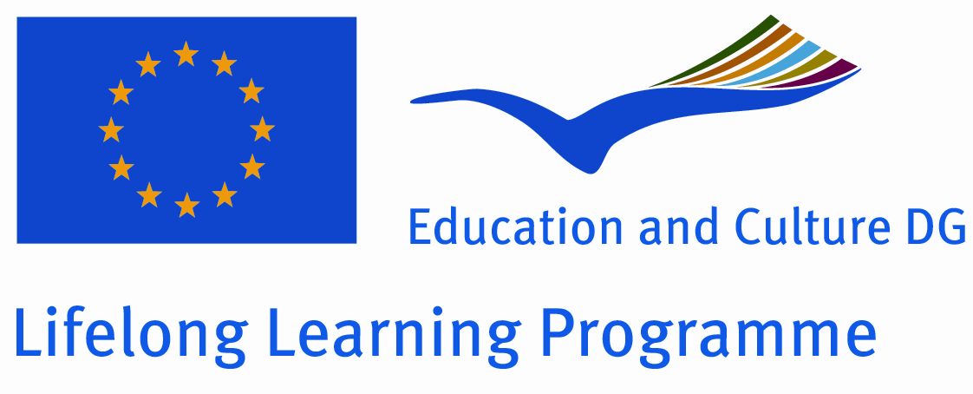 | International Conference  The Role of Intercultural Communication in Adaptation of Ethnic Groups to European Union Social Space  Oradea, Romania, 04-06 April 2019 | 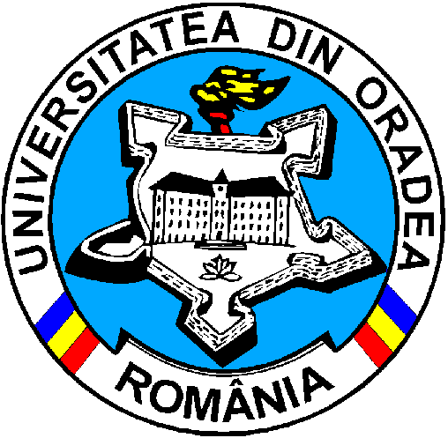

APPLICATION FORM

To be returned to the UNIVERSITY OF ORADEA by 01 March 2019
by email to karla_barth@yahoo.com or mirceabrie@gmail.com

1. PLEASE FILL IN CONTACT INFORMATION – THANK YOU!
(We cannot be held responsible for mistakes resulting from wrong typing)
Mr Mrs
Name:
Academic degree:
Academic title:
Organisation:
Department:
Address:.
Postal Code & City:
Country:
Phone Mobile Phone:
Fax:+
Email:
Personal information (name, address and email) is intended only for the express purpose of organising the event. This information may, therefore, be disseminated electronically or on paper and conferred to other participants in the interest of facilitating communication among them.

Should you prefer your e-mail address not to appear in any documents, please tick here:

2. PARTICIPATION

> WORKSHOP - Please confirm your attendance:
YES I will attend the international conference
Title of a paper: …………………………….…………………………………………………………………….
Topic of report, in which breakup group is to be presented: ……………………………………………………..
Abstract (max. 250 words):

Short biography of authors (max. 150 words:

3. HOTEL ACCOMMODATION
Accommodation expenses (breakfast included, other services excluded) for maximum 2 nights will be covered by the Organizations. The University of Oradea will deal directly with the hotel and will inform you on the name and address in return. If you wish to arrive earlier or stay longer, it is possible at your own expense provided that you give us a credit card number to guarantee the room reservation.
Any reservation made by yourself will not be subject to reimbursement. Any surcharges on site due to changes, incidentals or extras must be settled directly with the hotel.
Hotel reservation required? Yes No
Arrival date: ... / ... / 2019 Departure date: ... / ... / 2019 Number of nights: ...

